IT2120 – Probability and Statistics

Perera H.G.K.D

IT24104143

01)

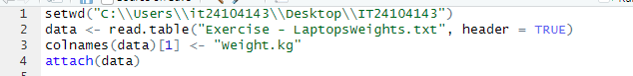

02)

03)

